|  |  |
| --- | --- |
| **Team ID** | PNT2022TMID24262 |
| **Project Title** | Signs with Smart Connectivity for Better Road Safety |

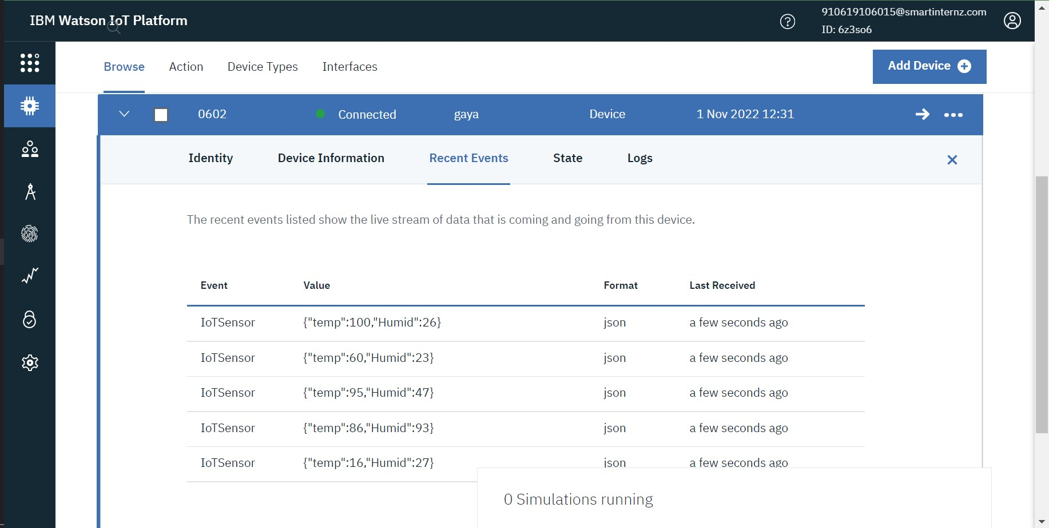

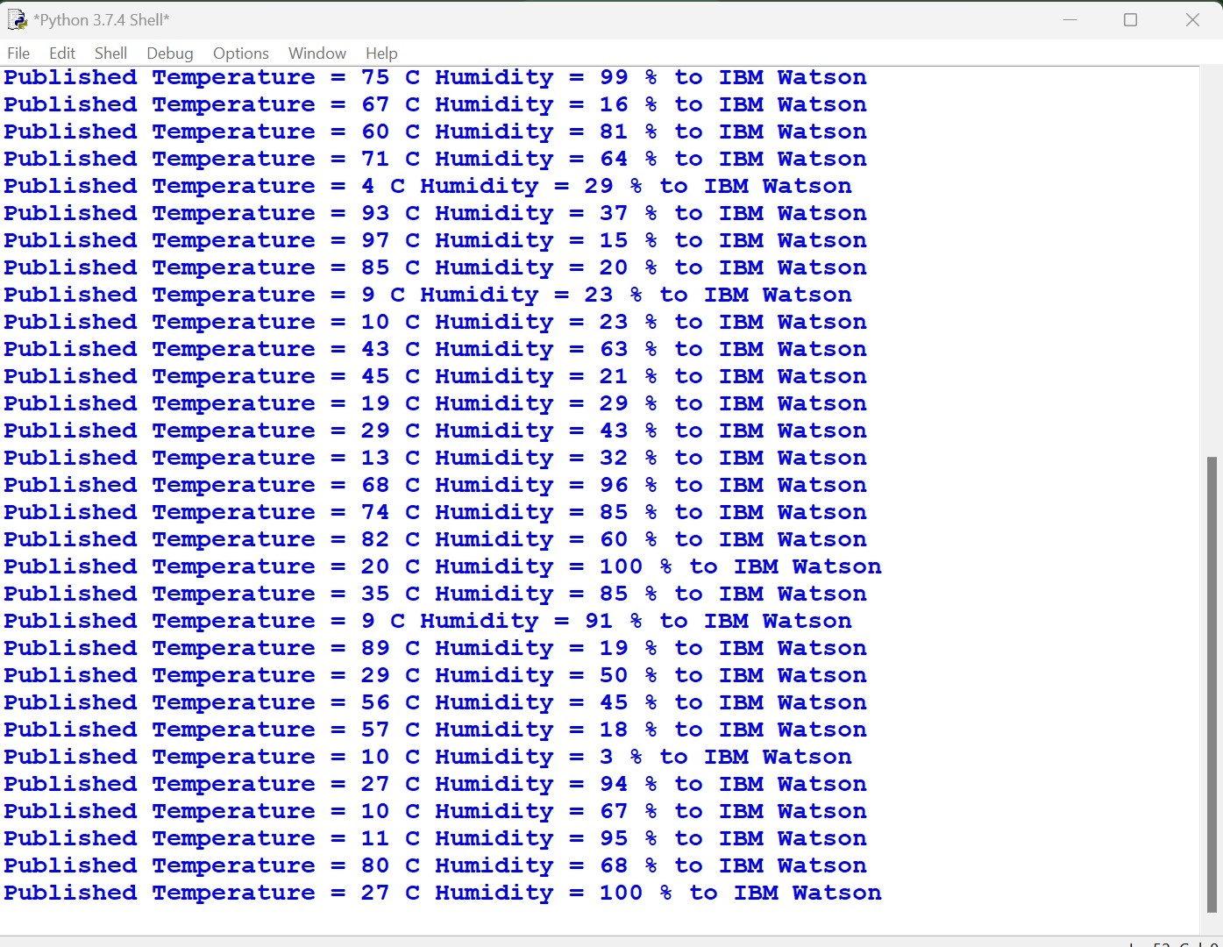

**Python Code:**

import time import sys import ibmiotf.application import ibmiotf.device import random

#Provide your IBM Watson Device Credentials organization = "6z3so6" deviceType = "gaya" deviceId = "0602" authMethod = "token" authToken = "gaya12345"

# Initialize GPIO

def myCommandCallback(cmd): print("Command received: %s" % cmd.data['command']) status=cmd.data['command'] if status=="switchon": print ("Switch is on")

else : print ("Switch is off")

#print(cmd)

try:

deviceOptions = {"org": organization, "type": deviceType, "id": deviceId,

"auth-method": authMethod, "auth-token": authToken} deviceCli = ibmiotf.device.Client(deviceOptions)

#..............................................

except Exception as e:

print("Caught exception connecting device: %s" % str(e)) sys.exit()

# Connect and send a datapoint "hello" with value "world" into the cloud as an event of type

"greeting" 10 times deviceCli.connect()

while True:

#Get Sensor Data from DHT11

temp=random.randint(0,100) Humid=random.randint(0,100)

data = { 'temp' : temp, 'Humid': Humid}

#print data def myOnPublishCallback():

print ("Published Temperature = %s C" % temp, "Humidity = %s %%" % Humid,"to

IBM Watson")

success = deviceCli.publishEvent("IoTSensor", "json", data, qos=0,

on_publish=myOnPublishCallback) if not success:

print("Not connected to IoTF")

time.sleep(1) deviceCli.commandCallback = myCommandCallback

# Disconnect the device and application from the cloud deviceCli.disconnect()